GWENT FEDERATION OF YOUNG FARMERS’ CLUBS
President : Mr Alun Morgan Chairman : Miss Abbie Williams Organiser: Mrs Jemma Rodgers

YFC Office,
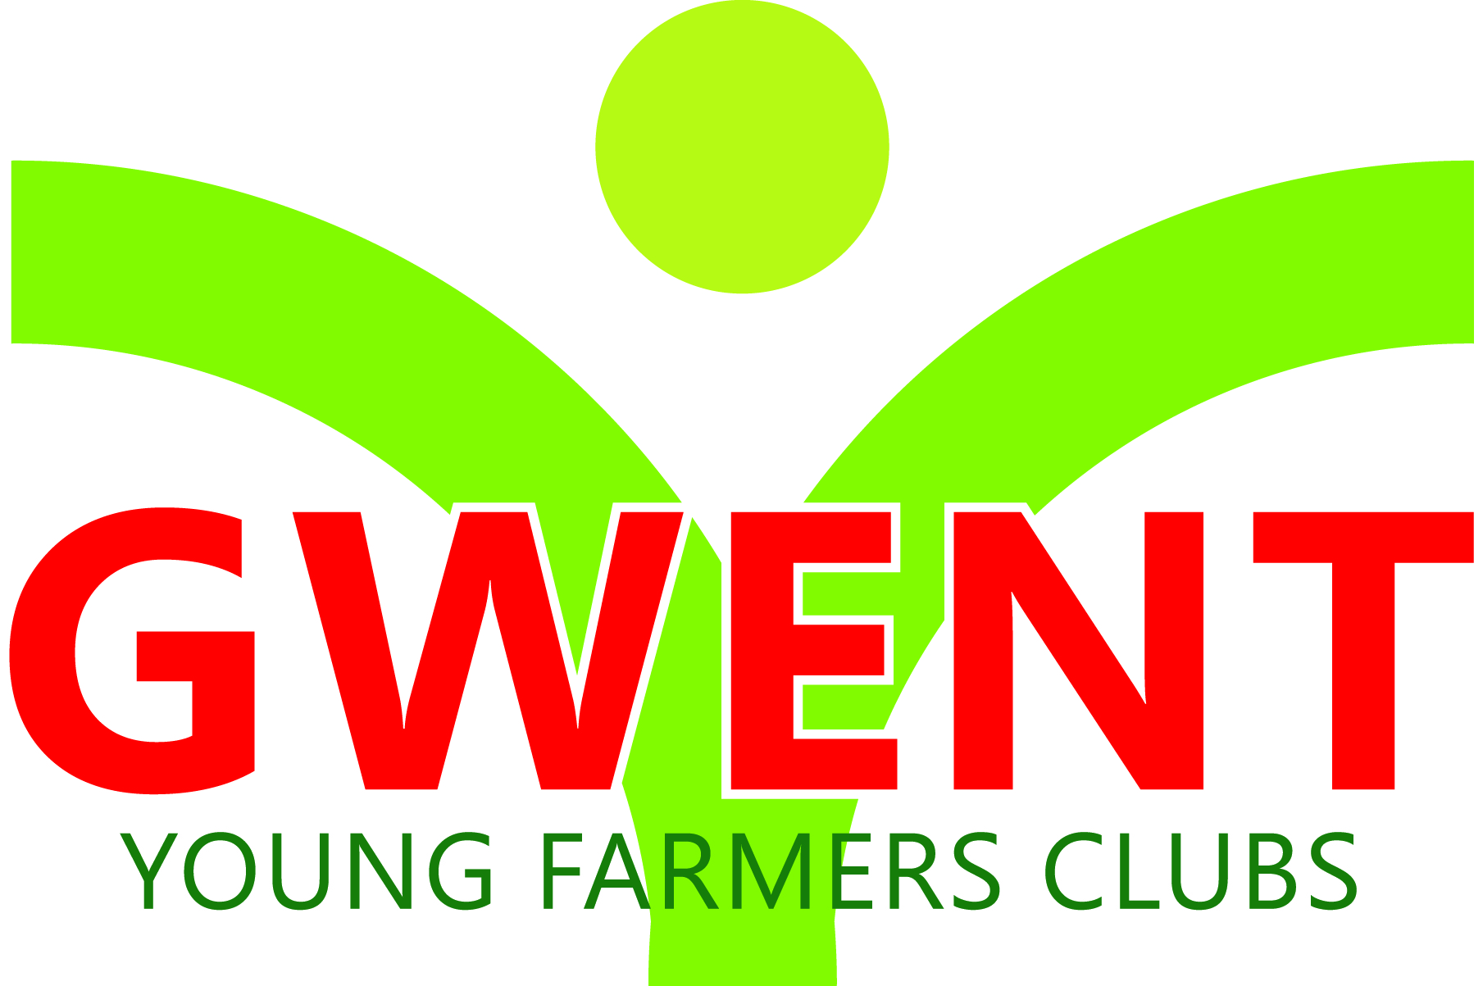
Coleg Gwent,
Usk Campus,
Usk,
Monmouthshire,
NP15 1XJ.
Tel :01291 672602
gwent@yfc-wales.org.uk
www.gwentyfc.co.uk
Monday, 24 May 2021

Dear Member,

The next meeting of the Competitions & Executive Committee will take place on Monday 24th May 2021 at 8.00pm on zoom.

Please make sure that all your Club Representatives are aware of the meeting, and that you have discussed the points on the Agenda, and that your Club views are put forward. Further copies of the agenda will be available on the night.

Yours faithfully

Abbie Williams
County Chairman
AGENDA

- Apologies
- Minutes: to receive minutes of the last meeting held on Monday 26th April 2021 (22/co/21 – 32/co/21)
- Matters Arising
- Correspondence
- Review of past 4 weeks
- Update from Wales/NFYFC meetings
- Competition’s calendar
- Highland cattle 25t^{h} April - virtual
- Sheep shearing/wool handling 4th June
- Texels 8th June
- TOW 17th & 18th June
- Rally 26th June
- COVID Update
- Welly
- Presidents Party
- Bills
- Proposal from management meeting
- AOB

Next meeting 28th June 2021

